How to identify neglect through the voice of the child

Hammersmith and Fulham LSCP are pleased to share this guidance for use with Children aged 0-18 to identify

issues of neglect and give you confidence to respond accordingly. This guidance was developed by Catherine McArevey

who is a Specialist Safeguarding Practitioner at Hertfordshire LSCP in 2021, and we are grateful for her permission to use this resource.

**This guidance has been divided into 3 sections:**

* For unborn children – 2 years old
* Children aged 3 - 11 years old
* Children aged 12 – 18 years old

This guidance has been developed to promote communication with children to find out directly from them how any issues of neglect are affecting them, and to help you talk about it with them. The resource aimed at unborn children to those aged up to 3 will, need you to put yourselves into the shoes of the child and be curious about the world going on around them. For older children aged 3 – 18 who are verbal, you will be able to ask them questions directly about what life is like for them.

If there are any red answers, please discuss with your supervisor to help you think about next steps.

**Voice of the Child**

**–**

**Could this be Neglect?**

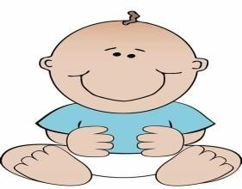

Is my home

clean and

free

from

clutter

?

Yes/

No

Do I have my own

safe

sleeping area free from

clutter? *

Yes/

No

Are there age appropriate safety measures for me?

Yes/

No

Am I safe from pets?

Yes/

No

Do I look physically healthy? i.e weight, skin condition

Yes/

No

Are my clothes clean, dry, well

-

fitting and suit the weather?

Yes/

No

Am I taken to my medical appointments?

Yes/

No

Is medical advice for my care followed?

Yes/

No



Are there easily accessible toys available, with no

Yes/

No

obvious choking hazards?

Do I feel

love and affection?

Yes/

No

***********************************************

Do I have lo

ts of accidents?

Yes

/No

Am I exposed to domestic abuse?

Yes

/No

Am I around people who abuse substances?

Yes

/No

Is anyone concerned

about me being neglected

?

Yes/

No

Are there any adults in my life who may be unsafe?

Yes/

No



.

*A safe sleeping area is their

own cot/crib/

Moses

basket. No bed sharing. No objects in or around the sleeping area i.e.

teddy bears, cot bumpers, drapes, washing etc and baby should be sleeping with feet at the bottom of the cot. Smoke

free environment.



Name:

Address:

Date of Birt

h or estimated due date:



**Age**

**-**

**Unborn to**

**2**

Please help me share my voice. Please complete every time you see me

even if you are not able to answer all the questions.

**Voice of the Child**

**–**

**Could this be Neglect?**



Is my home clean and

free from clutter

?

Yes/

No

Do I

have my own

sleeping area free from clutter?

Yes/

No

Am I given appropriate boundaries/discipline?

Yes/

No

Do I attend education

regularly with everything I need?

Yes/

No

Do I look physically healthy?

i.e.

weight, skin condition

Yes/

No

Are my clothes clean, dry, well

-

fitting

and suit the weather

?

Yes/

No

Am I happy to talk about life at home

and my carers

?

Yes/

No

Do I have adequate supervision?

Yes/

No

Do I have a range of toys and books to play with?

Yes/

No



Am I taken to m

y

medical appointments?

Yes/

No

Is medical advice

for my care

followed?

Yes/

No

Would

I feel loved and cared for

?

Yes/

No

***********************************************

Do I have caring responsibilities?

Yes

/No

Am I exposed to domestic abuse?

Yes

/No

Am I around people who abuse substances?

Yes

/No

Is anyone concerned about

me being

Neglect

ed

?

Yes/

No

Are there any adults in my life who may be unsafe?

Yes/

No



Name:

Address:

Date of Birth:



**Age**

**-**

**3**

**–**

**11**

Please hel

p me share my voice.

I may be able to answer some questions

myself if you talk to me.

Please complete every time you see me even if

you are not able to answer all the questions.

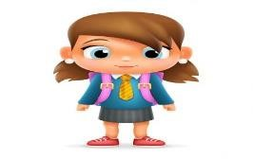

If there are any red answers, please discuss with your supervisor to help you think about next steps.

**Voice of the Child**

**–**

**Could this be Neglect?**



Is my home

clean and

safe for me?

Yes/

No

Do I have my own sleeping area free from clutter?

Yes/

No

Am I given appropriate boundaries/discipline?

Yes/

No

Do I attend education regularly with everything I need?

Yes/

No

Do I look

physically

healthy

?

i.e

weight

, skin condition

Yes/

No

Are my cloth

es clean, dry, well

-

fitting and

suit the weather

?

Yes/

No

Am I happy to talk about life at home

and my carers

?

Yes/

No

Do I feel loved and cared for?

Yes/

No

Do I have access to a range of social activities?

Yes/

No



Am I supported to

attend a

ll my medical appointments?

Yes/

No

Do I or my carers follow

medical advice

for m

e

?

Yes/

No

***********************************************

Am I spending lots of time sleeping at other people’s homes

Yes/

No

Do I have

caring responsibilities?

Yes

/No

Am I exposed to domestic abuse?

Yes

/No

Am I around people who abuse substances?

Yes

/No

Is anyone concerned

about me being neglected

?

Yes/

No

Are there any adults in my life who may be unsafe?

Yes/

No



Name:

Addres

s:

Date of Birth:



**Age**

**–**

**12**

**-**

**18**

Please help me share my voice. I may be able to answer some questions myself if

you talk to me. I am still a child until I am 18 and neglect may be harder to see.

Please complete every time you see me even if you are not able to answer all the

questions.

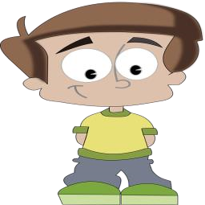

If there are any red answers, please discuss with your supervisor to help you think about next steps.