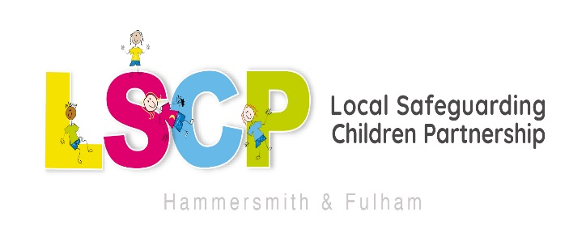

Freedom of Information: Guidance

Freedom of Information Requests (FOI) The Freedom of Information Act 2000 (FOI) provides the public with a general right of access to information held by public bodies, such as local government, the police, the NHS and state schools.

Hammersmith & Fulham Safeguarding Children Partnership (H&F LSCP) is a statutory partnership in its own right set up under the Children Act 2004 and is not a public authority for the purposes of the FOI. It is therefore exempt from the duty to provide information under the FOI.

Section 3 of the FOI provides that: (2) For the purposes of this Act, information is held by a public authority if— (a) it is held by the authority, otherwise than on behalf of another person, or (b) it is held by another person on behalf of the authority. A FOI request may be made directly to partner agencies of the H&F LSCP.

Where a H&F LSCP partner which is deemed to be a public authority under the FOI holds information for its own purposes, then it does so otherwise than on behalf of another person and the information held will be subject to the FOI.

However, partners in possession of H&F LSCP minutes, documents, reports etc. are holding this information on behalf of ‘another person’ (the H&F LSCP) and it is therefore not liable to disclosure under a FOI request.

Details of how to access information from a public body can be found on the Information Commissioner’s website at Information Commissioner's Office

