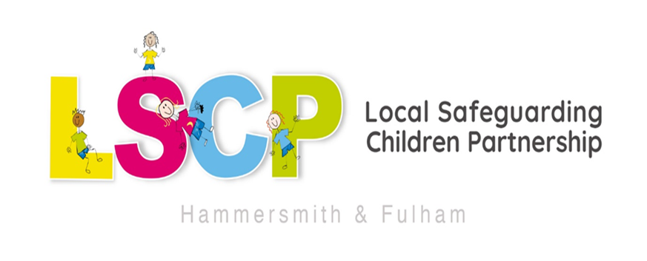

HAMMERSMITH & FULHAM
SAFEGUARDING CHILDREN
PARTNERSHIP ARRANGEMENTS

Published: | October 2025
Review Arrangements: | These arrangements will be reviewed on an annual basis by the LSCP Executive Board


Contents
Introduction Page 2
Vision, priorities and planning Page 2
- Our vision Page 2
- Priorities Page 3
- Business Plan Page 3
Governance & Structure Page 4
- Executive Board Page 5
- Working in Partnership Page 6
- Chairing Arrangements Page 7
- Safeguarding Children Partnership Forum Page 7
- Subgroups Page 8
  - Partnership Group Page 9
  - Learning & Development Group Page 9
  - Case Review Group Page 10
  - Quality Performance and Challenge Group Page 10
  - Safeguarding in Education Group Page 11
- Independent Scrutiny Page 11
Business Management Page 12
- Managing the Safeguarding Children Partnership Page 13
- Reporting Page 13
Participation Page 14
- Voice of the Child Page 14
- Consultation with children and their families Page 15
- Role of Education and Early Years Page 15
Learning and Development Page 15
- Local Child Safeguarding Practice Reviews Page 15
- Multiagency training Page 16
- Section 11 audits Page 17
- Themed multiagency audits Page 17
Working as a Partnership Page 18
- Relationship with other Governance Boards Page 18
- Thresholds for intervention Page 18
- Information sharing Page 19
- Freedom of information Page 19
- Financial arrangements Page 19
- Challenge, escalation and dispute resolution Page 19
Appendix Page 20
- Our legal frameworks Page 20
Introduction
This document sets out the agreed partnership arrangements for safeguarding children and young people in the London Borough of Hammersmith and Fulham. These arrangements will commence from 1st January 2025. These arrangements are in accordance with the Children and Social Work Act in 2017 and the revised statutory guidance Working Together 2023: both of which set out what is expected of organisations, individually and jointly, to safeguard and promote the welfare of children.

Hammersmith and Fulham’s arrangements have been designed to build on and enhance the pre-existing engagement of a range of partner agencies discharging the above responsibilities as members of the Hammersmith & Fulham Local Safeguarding Children Partnership. The arrangements reflect the new legislative requirements, particularly the statutory leadership roles of the three safeguarding partners, now known as the Lead Safeguarding Partners – local authorities, integrated care boards and police.

In 2024 Hammersmith & Fulham Children’s Services was rated outstanding by Ofsted. The Ofsted report highlights the strengths of the Partnership arrangements
Disaggregation from the tri-borough arrangements from April 2018, and the establishment of a sovereign local safeguarding children’s partnership, have involved significant transformation, and considerable complexity. Against this background, senior leaders have successfully navigated the changes needed to sustain and strengthen services for children in the borough.

Vision, Priorities and Planning
Our vision
It is our ambition that all children living in Hammersmith & Fulham area are able to grow up in circumstances where they are safe from harm, enjoy a healthy life, including having good mental health and emotional wellbeing and have opportunities to achieve good outcomes. Children are at the core of everything we do. The voice of children and young people is a cross-cutting priority, and their views will influence the strategic priorities and work of the Safeguarding Children Partnership. We believe that safeguarding children is everyone’s responsibility and want to ensure that this is achieved through a strong coordinated multiagency approach. We will work together to find the best way to drive improvements to practice and service delivery and will regularly evaluate our work to ensure we are achieving our goals.

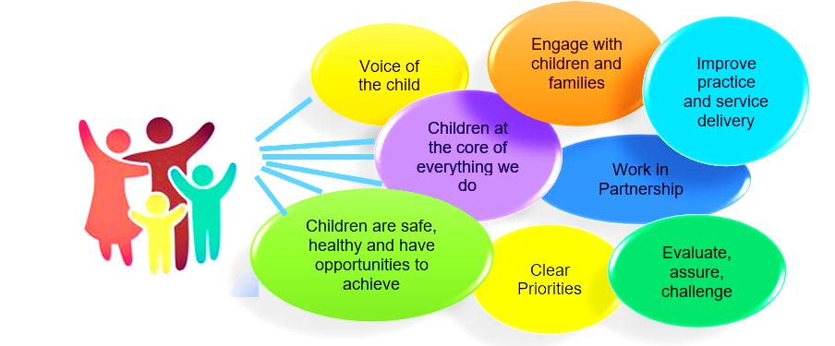
Our Priorities
2025–2027 LSCP Priorities
The LSCP priorities have been refreshed for the 2025–2027 period following extensive consultation with young people and our multi-agency partners. This collaborative process has directly shaped our new strategic focus and associated workstreams, effective from 1 April 2025.

We engaged young people through surveys and direct conversations, guided by insights from the Youth Council’s own research. In parallel, we convened an LSCP Development Day with our partners to refine and agree the direction of travel.

This process led to the identification of three core priorities and three cross-cutting themes, each tailored to the needs of Hammersmith & Fulham, with clear outcomes and deliverable workstreams.

Core Priorities
Priority 1: Staying Safe
- Safeguarding Adolescents
- Responding to Child Sexual Abuse
- Strengthening the Protective Role of Education

Priority 2: Early Identification and Prevention
- Promoting Proactive, Preventative Practice
- Embedding Family-Led Decision Making
- Improving School Attendance through Strategic Education Partnerships

Priority 3: Think Family
- Transitional Safeguarding
- Domestic Abuse Response
- Whole-Family Working

Cross-Cutting Themes
These themes underpin all priorities and are integral to our safeguarding approach:
- Voice of the Child
- Anti-Racist Practice
- Multi-Agency Information Sharing

These principles will be embedded across all safeguarding activity, ensuring our work remains inclusive, evidence-informed, and responsive to the lived experiences of children and families in H&F.

Business Plan
The Annual Business Plan cycle runs from April to March and will be influenced by statutory duties, and responsibilities, the strategic direction set by the Executive Board, and key areas of local and national learning. We will also remain diligent to outcomes from Quality Assurance activities such as audits or deep dives, which will be carried out to test effectiveness and understand impact.

Governance and Structure

Working Together to Safeguard Children (2023) outlines new responsibilities relating to the three Safeguarding Partners, namely the Local Authority, Police and Integrated Care Board. The Head of each of the statutory safeguarding partners is referred to as the Lead Safeguarding Partner (LSP)

For Hammersmith and Fulham, LSPs are:
- Chief Executive, Hammersmith and Fulham Council
- Chief Executive Officer, North West London Integrated Care Board
- Assistant Commissioner, Metropolitan Police

The LSPs may delegate the responsibility and authority for ensuring full participation with these arrangements to Delegated Safeguarding Partners (DSPs) but remain accountable for any actions or decisions taken on behalf of their agency.
The Delegated Safeguarding Partners have delegated authority to:
- make decisions on behalf of their organisation or agency regarding policy, resourcing and practice matters
- hold their own organisation to account on how effectively they participate in and implement the local arrangements

In Hammersmith and Fulham, the LSPs have identified the following senior officers in their respective agencies as DSP’s:
- Executive Director of People’s Services, Hammersmith and Fulham Council
- Director of Education and SEND
- Chief Nursing Officer, North West London Integrated Care Board (ICB)
- Detective Chief Superintendent and BCU Commander, Central West BCU

*There may be times when for operational reasons DSPs will need to delegate their role:
The Executive Director of People’s Services to the Operational Director of Children & Young People Services
The Chief Nursing Officer to Director of Nursing
The DCS Borough Commander to the Detective Superintendent (Head of Public Protection)

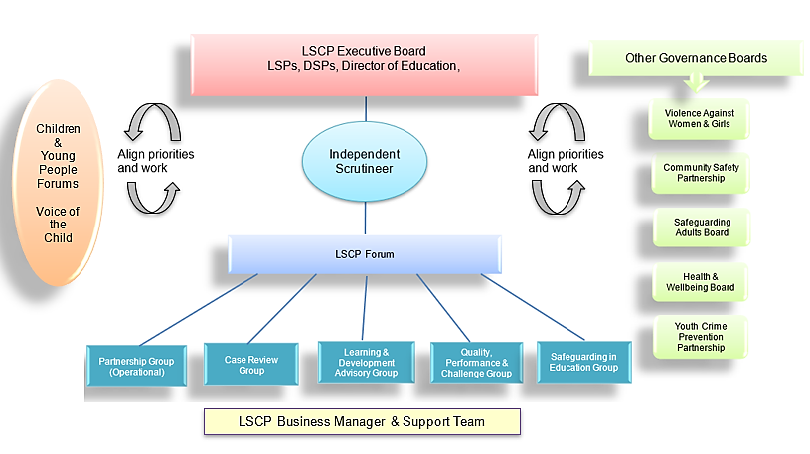

The Executive Board
Membership: The LSPs, DSPs, and Director of Education, will form the Executive Board.

The Executive Board will fulfil the objectives, functions and responsibilities set out in Working Together 2023 to safeguard and promote the welfare of all children in Hammersmith and Fulham
- Setting the vision, strategy and priorities for Hammersmith & Fulham’s safeguarding arrangements
- Delivering an accountable multi agency system for safeguarding and protecting children in all settings
- Challenging and holding the partners across all agencies to account
Agreeing, publishing and reviewing the safeguarding arrangements
- Monitoring serious child safeguarding cases which raise issues of importance
- Ensuring that the arrangements to work together to identify and respond to the needs of children in the area are effective and robust
- Making provision for independent scrutiny of the safeguarding arrangements
- Producing a Business Plan and Annual Report

The Executive Board will meet three times a year. The LSPs will attend the Executive Board
meeting once a year. The meetings of the Executive Board will not be held in public.
Working in Partnership
The Hammersmith and Fulham LSCP comprises a wide range of safeguarding partner organisations or ‘relevant agencies’ as they are described in Working Together 2023, and key stakeholder.

These partner organisations and stakeholders have been chosen as they provide key strategic and operational insight to the safeguarding of children and young people in Hammersmith and Fulham and these selected relevant agencies will form the core membership of the Hammersmith and Fulham Safeguarding Children Partnership Forum

Relevant agencies, safeguarding partners and key stakeholders include but are not limited to:
- Cabinet Member for Children
- Children’s Services (Children & Young People Services, Disabled Children Services, Education, Safeguarding, Early Help)
- Housing
- Adult Social Care
- Public Health
- Community Safety Team
- Metropolitan Police Central West Borough Command Unit (BCU)
- NWL Designated Health Professionals
- North West London IBC
- Imperial College NHS Trust
- Chelsea and Westminster NHS Trust
- Central London Community Healthcare Trust
- West London NHS Trust
- Lay Person
- Voluntary organisations
- Faith groups
- National Probation Service
- London Ambulance Service
- Education providers, including SEN schools
- Early Years providers
- Violence Against Women and Girls Strategic Partnership
- CAFCASS

The Executive Board also recognises the importance of involving the local community in the arrangements and have agreed to retain the existing lay member. Additional Lay Members may be recruited.

The lay member/s will act as valuable ambassadors to help build stronger links with the local community as part of the new arrangements and are encouraged to:
- promote awareness of safeguarding across Hammersmith and Fulham’s communities
- represent the community voice at Safeguarding Forum meetings

Chairing Arrangements
The Safeguarding Children Partnership Forum will be chaired by one of the DSPs, commencing with the DSP for the police, and will rotate on an annual basis.

The role of the Chair is to:
- Develop strategic links with, and between, the Forum members
- Support the LSPs in fulfilling their safeguarding duties for children.
- Ensure that local arrangements are designed to work collaboratively and effectively by encouraging and supporting the development of partnership working between the LSPs, DSPs, independent scrutiny role and subgroups.
- Chair the Executive Board meetings, and any additional meetings convened as a response to specific and exceptional circumstances, with the help of the business manager and independent scrutiny role.
- Offer appropriate challenge to ensure that the partners are accountable, and that the local arrangements operate effectively.

Safeguarding Children Partnership Forum
The Safeguarding Children Partnership Forum is a strategic partnership meeting comprised of the relevant agencies, safeguarding partners and key stakeholders and is accountable to the Executive Board.
The Forum will support the Executive Board in
- driving delivery of the local safeguarding priorities set by the Executive Board
- building relationships with other strategic partnerships, the local community, and schools and other educational establishments
- seeking assurance on behalf of the Executive Board that partners are fulfilling their safeguarding responsibilities, sharing information effectively and have robust safeguarding policies, and procedures in place through multi-agency audits (including S.11 audit) and Forum meetings. Oversight of which remains with the Quality, Performance and Challenge subgroup.
- developing, implementing and monitoring the impact of an interagency safeguarding children learning and development offer, incorporating local and national learning from serious child safeguarding reviews.
- analysing and considering partnership responses to any new safeguarding issues and emerging threats identified by the Executive Board
- ensuring safeguarding oversight and scrutiny arrangements include the voices of children and families in Hammersmith and Fulham
- agreeing a way of reporting and using multi-agency management information, data and intelligence to establish an overview of and assess the effectiveness of safeguarding activity within Hammersmith and Fulham
- developing an annual work programme for agreement by the Executive Board
- overseeing and guiding the work of the agreed priority groups.

The Forum will meet quarterly. Meetings of the Forum will not be held in public.
Attendance at all Forum meetings will be monitored and reported as part of the Executive Board annual report.

Subgroups
Five subgroups will report to and inform the work of the Executive Board and Forum
- The Local Safeguarding Children Partnership Group
- Case Review Group
- Quality Performance and Challenge Group
- Learning and Development Group
- Safeguarding in Education Group (under consideration)

The Partnership Group
The Hammersmith & Fulham Partnership Group is accountable to the LSCP Forum and is chaired by the Head of Safeguarding.

The Partnership Group is an operational partner collaboration that responds to safeguarding issues arising within frontline services and practice across the multiagency network, delivers on the priorities and policies of the LSCP at the
front line, and acts as a vehicle to influence the strategic direction and priorities of
the LSCP.

The Partnership Group is responsible for:
- Supporting the delivery of the local safeguarding priorities of the Partnership
- Building and maintaining relationships with partner agencies, voluntary agencies and the community
- Connecting the LSCP to front line practitioners, managers and safeguarding leads across the council, multiagency network and voluntary agencies
- Ensuring safeguarding oversight and scrutiny arrangements include the voices of children and families in Hammersmith and Fulham
- Supporting agencies to resolve issues and disputes
- Offering challenge to partner and voluntary agencies regarding safeguarding practice and delivery of services
- Ensure learning is disseminated across the multiagency network
- Establishing an understanding of the issues affecting and impacting on agencies ability to safeguard children in Hammersmith & Fulham and report this information to the LSCP Forum and Executive Board
- To share information with the Forum and Executive Board to assist in addressing and developing strategies to address the safety of children in Hammersmith & Fulham
- Escalate issues that cannot be resolved at an operational level

Learning and Development Group.
The Learning and Development Group will be responsible for:
- Demonstrating how we are making an impact and achieving positive outcomes for children and families
- promoting learning and best practice
- promoting learning around identified local and national priorities
- promoting learning from local and national learning reviews and audits
- providing updates on the progress and the impact of the multi-agency learning offer
- providing recommendations and suggested actions to improve multi-agency practice through learning and development in Hammersmith and Fulham

Case Review Group
The Case Review Group will be responsible for:
- identifying lessons from Rapid Reviews and local and national LCSPRs, and ensuring the learning is cascaded across the partnership
- developing action/improvement plans arising from each Rapid Review or LCSPR
- monitor progress of learning and practice development from reviews
- network with other subgroups to ensure action plans and / or learning are implemented.
- Consider cases not meeting the criteria but identified as providing multi agency learning
- making recommendations for multi-agency learning events based on the findings arising from Rapid Reviews and LCSPRs
- identifying and sharing examples of good practice to develop understanding of what works well
- working to local information sharing protocols to ensure timely sharing of relevant information

Quality, Performance and Challenge Group
The focus of the Quality, Performance and Challenge Group is to ensure that learning is promoted and embedded across the multiagency network, and to monitor, evaluate, analyse and evidence the of impact and effectiveness of what is being achieved

The Quality Performance and Challenge Group will be responsible for:
- Agreeing and delivering a multiagency audit programme, based on local priorities and emerging needs, to help measure the quality, effectiveness and outcomes of safeguarding work across the partnership.
- Analysis of a multi-agency data set
- Monitoring and evaluating the effectiveness of what is being achieved by partners, individually and collectively within the context of partnership safeguarding activities
- Ensuring gaps in performance are understood, communicated and actioned
- Identifying new and emerging concerns

In addition, the Executive Board may decide to set up specific short life working groups to consider particular emerging local or national priorities or initiatives.

Safeguarding in Education Group (under development)
The Safeguarding in Education group will meet to discuss on-the-ground safeguarding issues and support the wider strategic work of the LSCP.

This group will ensure that the voice of the education sector within H&F is heard and represented across the Partnership. It will monitor safeguarding activities across all the schools, provide a communication channel between education settings and act as a source of peer support in meeting safeguarding responsibilities.

The group will support and participate in the LSCPs Multiagency Quality Assurance activities where relevant.
The chair of the Safeguarding in Education group will sit on the Forum

Independent Scrutiny
Working Together to Safeguard Children 2023 has set out the arrangements for an independent scrutiny function, which should provide the critical challenge and appraisal of the multi-agency safeguarding arrangements. The role of the Scrutineer will be independent of the Hammersmith and Fulham Local Safeguarding Children Partnership.
The role of independent scrutiny is to provide assurance, through monitoring and challenge, in judging the effectiveness and quality of multi-agency arrangements to safeguard and promote the welfare of all children in a local area. This is undertaken through objective scrutiny, acting as a constructive critical friend, promoting reflection to drive improvements, and reporting how well the safeguarding partners are providing strong leadership to fulfil their safeguarding children role.

The Independent Scrutineer will work independently of the Executive Board and will:
- Provide safeguarding partners and relevant agencies with independent, rigorous, and effective support and challenge at both a strategic and operational level.
- Provide assurance to the whole system in judging the effectiveness of the multiagency safeguarding arrangements through a range of scrutiny methods.
- Ensure that statutory duties are being fulfilled, quality assurance mechanisms are in place, and that local child safeguarding practice reviews and national reviews are analysed, with key learning areas identified and effectively implemented across the safeguarding system.
- Ensure that the voice of children and families is considered as part of scrutiny and that this is at the heart of arrangements through direct feedback, informing policy and practice.
- Be regarded as a ‘critical friend’ and provide opportunities for two-way discussion and reflection between frontline practitioners and leaders. This will encourage and enable strong, clear, strategic leadership.
- Provide independent advice when there are disagreements between agencies and safeguarding partners and facilitate escalation procedures. • Evaluate and contribute to multi-agency safeguarding published arrangements and the annual report, alongside feeding into the wider accountability systems such as inspections
- provide assurance in judging the effectiveness of services to protect children on an annual basis
- assist when there is disagreement between the leaders responsible for protecting children in the agencies involved in multi-agency arrangements
- support a culture and environment conducive to robust scrutiny and constructive challenge

Business Management

Managing the Safeguarding Children Partnership
The day-to-day work of the LSCP will be undertaken by the LSCP Support Team led by the LSCP Business Manager. The team will provide organisational and administrative support for the Safeguarding Partnership and be responsible for the day to day running of the Partnership.

LSCP Business Manager will drive the development and ongoing operation of the Hammersmith & Fulham Safeguarding Children Partnership. They will manage and steer the multi-agency work for the Hammersmith & Fulham Safeguarding Partnership, taking responsibility for a range of monitoring and quality assurance activities to improve the outcomes for vulnerable children and will lead on all business planning against priorities agreed through the multiagency H&F LSCP and manage the production and timely delivery of Annual Reports.

The Business Manager will manage the LSCPs pooled budget and make recommendations
for decision making relating to the duties, priorities and future directions.

Reporting
Annual Reports:
To ensure accountability and transparency for children, families and practitioners about our activities and outcomes, the LSCP will produce an annual report. The annual report will outline the work the LSCP has undertaken over the previous 12-month period (April to March) and will be published on the LSCP website by the end of September each year.
The report will include a summary of:
- The effectiveness of the partnership arrangements
- The impact of the work of the Partnership on our priorities,
- Learning and actions taken or planned in relation to any local or national learning reviews,
- A report and analysis of training and its effectiveness
- How the voice of children and families has been used to inform and influence the LSCP and service delivery
- The impact the partnership is making on the lives of children and young people in Hammersmith & Fulham.

Update reports:
The Business Manager will provide a brief report outlining key activity of the partnership, subgroups, information and updates regarding any Rapid Reviews or Local Safeguarding Practice Reviews taking place, budget position and important national updates, to the Executive Board prior to each Executive Board meeting.

The Independent Scrutineer will provide the Executive Board with a brief report outlining key scrutiny activity and key challenges, prior to each Executive Board meeting.

Participation

The safeguarding partners and relevant partner agencies are responsible for
having processes in place for receiving feedback from children and their families
about the services received. This feedback should be used to inform the
development of services being delivered to improve the experiences of children
and parents/carers.

Voice of the child
The voice of the child is a key thread across all the work of the Partnership, and each subgroup will be required to highlight how it has considered this in their quarterly update to the Partnership. The voice of the child will also be further incorporated into the multiagency safeguarding training that we provide.

The Youth Voice Coordinator and the Participation Officer will liaise with the
Youth Council and Children in Care Council, and other local forums that our resident
children contribute to, and seek the voices and experiences of children and young people in
Hammersmith & Fulham in relation to safeguarding matters.

The Youth Voice Coordinator and the Participation Officer for the Children in Care Council will develop a cohort of young people, including children who are looked after and care leavers, who will act as Young Scrutineers for the Partnership. They will be invited to contribute to and scrutinise our local priorities and actions taken towards addressing these. Children and young people will be invited to scrutinise the LSCP annual report and help draft a version specifically for children and young people. We will consult with children and young people when developing any new partnership priorities and align priorities where appropriate.

Consultation and feedback with parents and carers
We will consult with and seek feedback from parents and carers on specific issues to ensure that its information is relevant and accessible. Examples of such consultations might include:
- Views about specific safeguarding issues
- Information leaflets aimed at parents/carers and children and young people
- The development of policies or good practice guidance when appropriate
- Content located on the parent/carer and children and young people specific areas of the H&F LSCP website

Role of Education and Early Years
The Executive Board recognises that early years settings, primary all schools and other education establishments (including colleges) are an important part of safeguarding in Hammersmith and Fulham. They have responsibility to identify concerns early, provide help for children and families and prevent concerns from escalating.

The Director of Education sits on our Executive Board and senior officers from SEND and from primary, secondary, education Special Educational Needs Schools, and Colleges are core members of the LSCP Forum.

The creation of the Safeguarding in Education subgroup will ensure that there is strong communication between the Partnership and education settings and that education settings are embedded as a key partner in the activity of the LSCP.

Learning and Development

Local Child Safeguarding Practice Reviews
Working Together 2023 lays out the responsibilities and criteria for reporting serious incidents, holding Rapid Reviews and commissioning Local Child Safeguarding Practice Reviews (LCSPR).

In line with this the safeguarding partners have agreed procedures to manage the consideration of cases that might meet the criteria for both national and local learning reviews.

Following notification to the National Panel, and the Secretary of State for Education, and
Ofsted if incident relates to the death of a looked after child, a meeting will be held between
the three partners where a decision will be reached about whether to hold a Rapid Review.
Should there be any disagreement regarding the decision the H&F LSCP dispute resolution process will be applied.

The Case Review Group, which comprises key safeguarding leads, will be the mechanism for carrying out a Rapid Review and will report to the safeguarding partners. All relevant agencies involved with the child or family will be invited to participate in the Rapid Review process. Rapid Reviews will be Chaired by the Independent Scrutineer.

Administration of Rapid Review meetings will be the responsibility of the LSCP Business Manager and Support Team.

For each Rapid Review, an action plan will be created to capture and monitor progress relating to key learning and actions. These action plans will be monitored and reviewed by the Case Review Group.

The final decision about conducting a LCSPR lies with the Executive Board. The National Panel is notified of the final decision.

When the criteria for a CSPR is met, the Executive Board will consider and make recommendations regarding the methodology, on a case-by-case base.

Multiagency Training
The Executive Board have agreed that Hammersmith & Fulham LSCP will maintain a shared multi-agency training offer in partnership with the Bi-Borough LSCP (Kensington & Chelsea and Westminster).

The offer will be coordinated by the Bi-Borough Learning and Development Coordinator, in collaboration with the Hammersmith & Fulham LSCP Business Manager, Head of Safeguarding and the multi-agency Learning and Development Group, which will report into the Safeguarding Forum.

The training offer will comprise of a range of different learning opportunities including:
- e-learning modules
- themed briefings
- awareness raising events
- joint learning events/sessions with other strategic partnerships including Hammersmith and Fulham Safeguarding Adults Board

Any recommendations for learning and development activity will be approved by the Executive Board.

Learning events held to either launch or conclude one of the safeguarding priorities will include the input of the Independent Scrutineer as well as any experts as appropriate. The Learning and Development Group will provide an annual update on the impact of the safeguarding learning and development programme to the Safeguarding Forum for inclusion in the annual report.

Section 11 Audits
Section 11 of the Children Act (2004) places duties on a range of organisations and individuals to ensure that their functions are discharged with regard to the need to safeguard and promote the welfare of children.

The Executive Board have agreed that the Quality Performance and Challenge Group will assess and monitor compliance by undertaking Section 11 audits. This has been acknowledged to be an effective way of providing assurance to the Executive Board that partners and agencies are meeting their statutory safeguarding obligations.

The Executive Board will review the frequency and methodology of S11 audits on an annual basis.

Themed Multiagency Audits
Multi-agency themed audits focussing on the identified safeguarding priorities will be built into the Safeguarding Forum’s annual work programme and carried out by the Quality Performance & Challenge group.

Working as a Partnership

Relationship with other Governance Boards
The Executive Board recognises that there is potential cross over in some areas of work and priorities with other strategic partnerships in Hammersmith and Fulham. The LSCP is committed to effective cross-partnership working to help ensure positive outcomes for children and young people.

The Independent Scrutineer and Business Manager will meet annually with the Chairs of the following partnerships to align strategic priorities, address gaps and reduce duplication of our work:
- Health and Wellbeing Board
- Safeguarding Adults Board
- Community Safety Partnership
- Violence Against Women and Girls Board
- Youth Crime Prevention Partnership

Thresholds for Intervention
Everyone who works with or has contact with children has a legal obligation to keep children safe. The London Safeguarding Procedures Threshold Document: Continuum of Help and Support is the threshold document employed by the Hammersmith & Fulham LSCP.

This Thresholds document is aimed at all practitioners and volunteers supporting or working with children and/or their families within statutory, voluntary, private or independent organisations in Hammersmith and Fulham. Along the continuum of need services become increasingly targeted and specialised according to the level of need. Children's needs are not static, and they may experience different needs – at different points on the continuum – throughout their childhood years. It aims to help individuals and organisations when making a referral for services to ensure children and families get the right level of support at the right time. It should be read alongside the London Safeguarding Children Procedures

Information sharing
Effective sharing of information between professionals and local agencies for safeguarding purposes is essential and the Executive Board expects all organisations in Hammersmith and Fulham to have arrangements in place which set out clearly the processes and the principles for sharing information between each other and with other professionals.
The Executive Board expects that all members of the Safeguarding Forum will:
- ensure that their own organisation’s Data Protection Registration and requirements under the General Data Protection Regulations 2018 (GDPR) meets the requirements
- adhere to the provisions of the Data Protection requirements as amended by the GPDR 2018 and maintain confidentiality at all times, other than where a specific exemption under the Act arises

Freedom of Information
As the Executive Board is not a ‘public authority’ (as defined by the Freedom of Information Act 2000 Act), there is no obligation to respond to approaches to the Executive Board for information made under the Act.

Financial Arrangements
The Executive Board will agree the annual contribution to the safeguarding partners funding required to meet the responsibilities, duties and objectives of the arrangements. This agreement will be reviewed on an annual basis.

The financial year will run from the 1 April to the 31 March the following year, with contributing agencies being invoiced by the 1st of October each year.

The income and expenditure will be managed and monitored by the LSCP Business Manager and Head of Safeguarding on behalf of the Executive Board.

The Executive Board will receive annual reports on the income and expenditure.
A comprehensive report identifying income and expenditure in line with Working Together 2023 requirements will be included in the Annual Report.

Challenge, escalation and dispute resolution
Occasionally situations arise when workers within one agency feel that the actions, inaction or decisions of another agency do not adequately safeguard a child. Differences and debates are all part of multi-agency working and escalation the Hammersmith & Fulham LSCP Escalation and Resolution guidance provides a useful framework to explore and resolve professional disagreements.
The Executive Board expects that:
- all agencies make use of escalation procedures to avoid exacerbating or prolonging conflict, and avoid any possible impact on children and young people
- all agencies have their own escalation and whistleblowing procedures and should use these (as appropriate) in the first instance
- agencies will have systems for recording when escalation policies are used and how disagreements are resolved
- all agencies should use the London Safeguarding Procedures professional conflict resolution procedures where there are disputes involving child protection procedures PA4. Resolving Professional Differences
- the terms of reference for all multi-agency panels and meetings includes reference to what to do if there is a disagreement

If it has not been possible to resolve professional differences between agencies, relating to safeguarding children, then this can be brought to the attention of the attention of
the Executive Board, supported by the Scrutineer who can, “Provide
independent advice when there are disagreements between agencies and safeguarding
partners and facilitate escalation procedures”.

Appendix

Our Legal Frameworks
The Hammersmith & Fulham Safeguarding Children Partnership (LSCP) is governed by, and adheres to different policies and procedures, developed in accordance with the "Working Together to Safeguard Children 2023" and other National Guidance.
London Safeguarding Children Procedures provide standards for agencies and a framework to promote children’s welfare and protect them from abuse and neglect.
Children's Act 1989
Children's Act 2004
Children and Social Work Act 2017
Keeping children safe in education 2024
Safeguarding Disabled Children Practice Guidance
Children's Social Care: Stable Homes, Built on Love
Children's Social Care: National Framework
Information sharing advice for safeguarding practitioners - GOV.UK (www.gov.uk)
FACT SHEET: A summary of the rights under the Convention on the Rights of the Child
The Munro Review of Child Protection: A Child-Centred System

Working together to safeguard children 2023: statutory guidance

